SOP of Ajit Bakery- **Report**

**Step 1.** Click on Report

**Step 2.** Click on **TAT Report.**

This TAT report allows the user to track the status and turnaround time of the product.

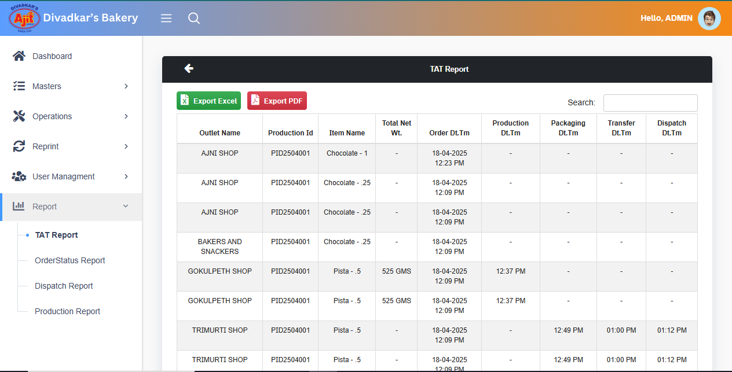

**Step 3.** Click on **Order Status Report**.

In this Order Status Report, the user can check the current status of their product orders.

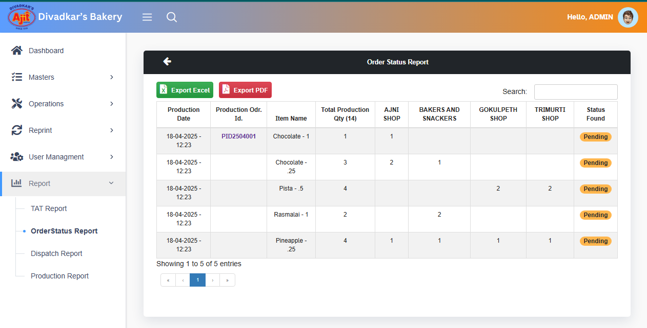

**Step 4.** Click on **Dispatch Report.**

The Dispatch Report allows users to track the number of orders along with their dispatch status.

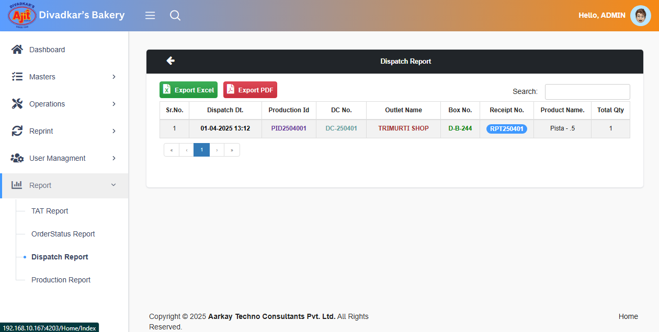

**Step 5.** Click on **Production Report.**

The Production Report provides details on the quantity of items produced.

